LAB 10 SCREENSHOTS FILE

Min Function

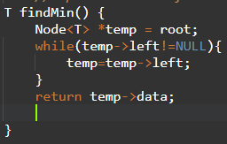

Max Function

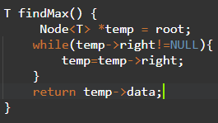

Console Output

